Final report on the internship

(*Front end intern)*

Student: Muskan Bhat

Student ID number: 636130

Degree programme: Bachelor’s Information technology

Email address: company [ssg@ythewait.com](mailto:ssg@ythewait.com)

Client: Y the wait

Company supervisor: Simranjit Singh Grewal

Supervising lecturer: Eef Stavenuiter

Place: Rivium 4e Straat 3, 2909LJ Capelle aan den Ijssel

Date: 14-01-2021

Version: version 1

# Contents

**Contents 1**

**1.** **Introduction 2**

**2.** **Company description 2**

**3.** **Description of activities 2**

3.1. Assignment ‘name 1’ 3

3.2. Assignment ‘name 2’ 4

3.3. Day-to-day activities 4

**4.** **Competence report 4**

**5.** **Evaluation 5**

**6.** **Appendices 5**

# Introduction

This is the interim document for the front end bootstrap, react JS-Redux internship I have started in “Y The Wait Operations BV”. My assignment is mainly divided into two parts. The first part consists of development of front end of the websites for businesses(merchants) registered with Y the wait. The merchants can be classified as restaurants, hotels, supermarkets, pharmacies, etc.

The second part consists of re-development of the front end of the website of backend dashboard for the clients. The existing version of admin dashboard uses front-end technologies HTML5, jQuery, and bootstrap and wanted to switch to ReactJS. It involves upgrade of the existing features of the dashboard as well adding new features in the dashboard.

This document is intended to provide an in-depth insight of what I did and learned in my Internship for me, the supervisor, and the company as well. This document will consist of information about the activities that I have done during my internship period and my personal reflection.

This document consists various parts mainly divided in 4 parts,

* Description of activities
* Competence Report
* Evaluation
* Appendices

# Company description

Y the wait is an extensive platform developed to provide hospitality features to various types of customers. The customers of the company include the an app user that uses app to access hospitality services of the business owners registered with Y The Wait, and the businesses registered with the company including restaurants, hotels, supermarkets, event halls, etc. The basic module contains the digital waiter service, delivery/takeaway/reservation, and exclusively for business owners, are the services like point of service software, staff app, etc.

The vision of Y the wait is to become the global dynamic leader in the hospitality industry through innovative solutions and their mission is to transform the way people experience their hospitality service globally. Their goal is to deliver everyone the food and service that they deserve in an honest and easy way. The core values that represent the company strongest are: Integrity, transparency, and a family-oriented company culture.

Company’s management philosophy is based on responsibility and mutual respect. They wish to maintain a work environment that fosters on personal and professional growth for all employees. Maintaining such an environment is the responsibility of every staff person. Because of their role, managers and supervisors have the additional responsibility to lead in a manner which fosters an environment of respect for each person.

The company is currently spreading globally, currently established in The Netherlands, Canada, USA, India, Lebanon, etc with over more than 7000 businesses registered with the company.

The technologies used by the company’s development teams involve HTML, JavaScript, PHP, CodeIgniter Framework, Reactjs, Redux, etc.

The Business model of Y The Wait is Peer to Peer which means that the end customer and merchants or vendor interact to buy sell services directly with each other without an intermediary third-party.

Y the Wait provides a lot of services via their platform, as it is aimed to serve as an all-in-one app for both business owners and app/website user who want to access their services. They do have competitors as well but having a wide range of facilities being provided makes them, unique in their field. However, some apps that provide similar services such as food ordering in The Netherlands are Thuisbezorgd, Uber eats, etc.

The services of Y the Wait are all about evolving hospitality service experience, it serves to eliminate all inconveniences people experience during a restaurant dine-in or a home delivery order. The app minimalizes waiting time in restaurants when you are craving for food.

* Service and food reinvented.
* Easy and user-friendly table planner
* Automatic allocation of tables available
* Allots a limitless number of rooms and tables
* Arrangement of the tables for large-scale events and parties

The main service Y The Wait provides to their clients is the User app and the ordering website. Meanwhile there are certain tools the company provides to the merchants to use their services, which can be classified as point of sale, the staff app, individual ordering website and the dashboard. The dashboard is a web-based admin panel used by the business owners such as any restaurant, supermarket, or hotel registered with Y The Wait, and is also used by the company data management team.

Moving on, the individual ordering websites provided to the merchants are used by the website users to access the products are services provided by the merchants. Each type of business has different template of ordering website depending on the type of services they provide, for example the ordering website for a merchant who has a restaurant registered would differ from the website for a supermarket and so on.

The dashboard has various purposes like registering businesses, entering data for the business owners, access to manage features like delivery, takeaway, reservations, discount coupons, revenue reports, and more essential functions.

Next up, is the user ordering platform, available in website and app versions is used for customer to prevail services provided by the business owners, for example a user can log in the user app, look for restaurants near them, order food for delivery or takeaway, reserve a place in the restaurants.

Further, the Point of sales, also available in website and app both are the platforms used by the business owners to manage their stocks, their, products, staff, revenue, reservations, orders, etc. Further, the staff app is used by waiters and delivery persons to keep track of the tasks assigned to them by their employer.

# Description of activities

The first part of my assignment consisted of developing the front-end for ordering website templates for different kinds of merchants registered with Y the Wait. The merchants can be classified as restaurants, hotels, supermarkets, pharmacies, etc.

The task was to develop the designs provided to me in HTMl css bootstrap and JS.

Next assignment was to rebuild a module/part of the front end, which is entirely made up of HTML5, jQuery, and bootstrap. The goal is to eliminate jQuery and rely entirely on JavaScript es6 and react with redux.

The super-admin dashboard is used by clients, be it business owners or the administrators of the website. It has access levels based on roles. As Y The wait is a globally growing company it’s reaching more and more customers every day, and this is why advancement of the product was required as the current website design is reportedly slower and primitive and therefor it was decided to re-build the front-end using react which is relatively faster and advanced to support a vast range of customers. Hence this part of the assignment solely focuses on improvement of the dashboard for convenience of the future and present clients.

## Assignment ‘Ordering Website’

This assignment consisted of making the front end of the websites for the merchants based on the different design templates provided which differs based on the business type of the merchants. The websites will be developed in HTML5, CSS, bootstrap, and Java Script.

It is an essential necessity for the businesses registered under Y the wait as these websites are the way website users would be able to view their products or services. The main clients here are the clients of Y The Wait who will avail their services for their businesses.

As every business type has a different kind of ordering website template to choose from, the assignment will be extensive and collaborative. I received the design from our design team, and I had to make the first template. After that it would get check by my senior developer colleague(s) and the website will go live after the backend functionalities are integrated as well.

### Approach

***Products to be delivered***

As I mentioned earlier, this assignment consisted of building the front end of ordering website templates for different kinds of merchants. For my assignment I received 2 types of design templates to make, both for restaurants but two different designs.

My approach towards completing my assignment defined according to SMART goals was,

Specific: My assignment was, developing the front-end for both the ordering websites for the merchants/business owners registered under Y The Wait using HTML5, CSS, JavaScript and bootstrap.

Measurable: I was provided a design of the web pages consisting of the website and I had to deliver the website HTML within a few weeks depending upon the type of website template as the design and requirements varied.

Attainable: The goals and expectations from me will be clear, and I was aware of what and how much was expected from me. I was also provided help and feedback from my seniors to guide about the quality of work I should deliver.

Relevant: The relevance of this assignments was high as my work will be integrated in the company's main services after it is checked by my senior developer colleague(s) and the websites will go live after the backend functionalities are integrated. And it was relevant for the development of my UX design skills.

Time-Based: My assignments were divided into smaller tasks. I was given weekly goals to fulfil, further divided in daily tasks and I reported every day and at the end of every week as week to inform about my progress.

***Approach: activities to be undertaken***

For this assignment I had to have knowledge of HTML CSS JS bootstrap, I didn't have experience with bootstrap but I got better with practice. My project leader provided me with designs and told me which screen I have to deliver by when and I made them. After I was done making the code for the screen, I sent it in as zip file in our team’s file sharing group. Then, my senior would check my work and let me know where are the areas of improvement and what I could avoid for the next time.

***Quality assurance***

The quality of work delivered will be supervised by the senior developer and the project team. They would check my work, provide feedback and necessary help. Usually, my senior colleague checked my work after my submission and gave me feedback, if the issues were too much in my submission, she would create a proper document to lay out my mistake and how they can be improved which was extremely helpful. After the back-end technologies are integrated with the front end I developed and the testing is done, the websites will go live that means my work will be an essential part of the company’s services.

Daily targets were set for me and I must report at the end of everyday if I met them or not and if not, then what are the issues I faced. Weekly meetings helped to discuss the work done, feedback and for discussing the next step of the assignment.

***Planning and organisation***

For the first 3 weeks, I prepared myself so I could understand React and redux since this was my first-time developing in ReactJS. After finishing my training, I started with development of ordering websites and received bootstrap training side by side from my colleague and lessons available online. As I explained above the course of my daily and weekly planning

The activities comprising first phase of my assignment have been translated into a Gantt chart (included in the appendix)

### Results

My assignment didn't start off as smoothly as I expected it to. My work got delayed because of my illness and my mistake of not asking for help on time but I worked on myself, worked on my incompetence and completed the assignment with the guidance and help of my supervisor and colleagues. Hence, after a lot of hit and trials and improvements based on helpful feedback via my mentor senior developer, I delivered my picture perfect ordering website pages with proper functionalities.

## Assignment ‘Dashboard Module Technology shift’

The assignment was to rebuild the front end, which is entirely made up of HTML5, jQuery, and bootstrap. The goal was to eliminate jQuery and rely entirely on JavaScript es6 and react with redux.

The super-admin dashboard is used by clients, be it business owners or the administrators of the website. It has access levels based on roles. As Y The wait is a globally growing company it’s reaching more and more customers every day, and this is why advancement of the product was required as the current website design is reportedly slower and primitive and therefor it was decided to re-build the front-end using react which is relatively faster and advanced to support a vast range of customers. Hence this part of the assignment focuses on improvement of the dashboard for convenience of the future and present clients.

The dashboard modules were made based on the new designs provided by the design team, the task was similar to what I did in phase 1, making the code live based on the design provided but this time in more advanced technologies.

### Approach

***Products to be delivered***

The purpose of this assignment was shifting dashboard front end technology to React redux for better compatibility. Which will further be followed by implementing functionality to that structure. The functionalities are further divided in to 5 main categories, customer registration, Data entry, Delivery/Takeaway/Reservation, Discounts, and Invoices.

The product I was developing for the dashboard was a part of Finances and Invoices, in reactjs and redux based on the design provided by the design team. The code was then be supervised by the senior developer and made live after back end was integrated and testing was done.

My approach towards completing my assignment defined according to SMART principles was,

Specific: My assignment was developing the front end for the admin dashboard for which I needed to have knowledge of ES6, React JS and Redux. I was provided the design prototype based on which I developed the code of the dashboard modules.

Measurable: Just like the previous assignment, I worked on this assignment focusing on smaller daily and weekly goals that combine to form the end product of the assignment which was Finance and Invoices Module of the Dashboard.

Attainable: The goals and expectations from me were clear, and I was aware of what and how much was expected from me. I was also provided help and feedback from my seniors to guide about the quality of work I should deliver.

Relevant: The relevance of this assignments was high as my work will be integrated in the company's main services after it is checked by my senior developer colleague. He guided me through the development process. This assignment was relevant to provide me knowledge of ReactJS and Redux development.

Time-Based: My assignments were divided into smaller tasks. I was given weekly goals to fulfil, further divided in daily tasks and I reported every day and at the end of every week as week to inform about my progress.

***Approach: activities to be undertaken***

While starting phase 2 assignment, my training for bootstrap, reactjs and redux was already completed which was beneficial for me to begin with the development of dashboard modules. I begun with revising the knowledge that I gained from my training prior jumping into the development. I was again provided the designs of the modules via figma from the design team.

Then, my senior decided to assign me the Finances and invoices module. After that, I developed of basic structure of the design using JSX and then make it interactive using ReactJS and Redux. Then the same process I followed in the first phase, I send in my product, my senior checks it, gives me feedbacks, points out areas of improvements and I ask for help if I need it, and that is how I improve quality of each fragment of my assignment based on feedbacks and suggestions and move on towards the completion of my assignment.

***Quality assurance***

For this assignment I had another mentor/senior colleague to help me out with the development, so I got to learn from another experienced person from the tech field about react development which is really exciting as reactJS is one of the most popular library used in web development to build interactive elements on websites. He checked and reviewed my code with me and explained me thoroughly what was happening in the code and why if I had doubts as I am fairly new in react development.

***Planning and organisation***

As explained before, for this assignment, the module designs/screens were provided in figma by my colleague Gurleen. After that my team leader Varun made a virtual workspace for me and assigned me Finances and Invoices module of the dashboard. In this assignment as well, my task were divided in daily and weekly goals. Then I would submit my work in the group file sharing platform and my colleague Sumit would monitor my code and guide me though the development process.

The activities comprising second phase of my assignment have been translated into a Gantt chart (included in the appendix)

### Results

This phases started off better than the last stage with definitely more positivity and excitement. I contributed in the development of the Invoices module of then dashboard using ReactJS Redux. I did it with the help of my generous colleagues guidance and support. As, currently I still didn’t reach the end of my phase 2 internship, I am still in the development and learning phase, and will end this assignment till my internship end date which is supposed to be 29-01-2021. I am happy about my progress form phase 1 to phase 2 and I learnt a lot about tech development in an official environment.

## Day-to-day activities

* I communicated with my team on our group message exchange platform (either Campfire or WhatsApp)
* I updated my team update about what I did yesterday, what are my goals for today and if any deliverable I have to deliver today
* After getting assigned my task, I would either call my senior colleague to help me out with starting off with the new assignment or start working on it on my own and ask for her/his help if I need it.
* I also socialized with colleagues from other department and often ask them how is their work is going on.
* I submit my daily work to my team or straight up my colleague(s) Sumit/Divya. After that submission they would heck my work either the same day or the next day and let me know where is room for improvement.
* At the end of the day, I inform in my group chat what work I have done today, how much I did today, what went wrong or what I need extra help with.
* If necessary, I would have a meeting with my supervisor about any issues I was facing with the team coordination or if I was lacking some resources such as softwares etc so he could arrange it for me via other tech development teams as well.

# Competence report

*This component will be about 1,000 – 1,500 words long.*

Two professional competences will be demonstrated, one of which must be the 'design' or 'realisation' competence (or both). The ‘professionalisation’ competence will be demonstrated too. A minimum of one performance indicator will be demonstrated at Level 2 for each competence. Competences will be demonstrated by means of the STARR method, based on two situations encountered in professional practice per performance indicator. As such, there will be a minimum of six situations in total.

The STARR method is described briefly below. Although you are not required to use this table, it is important to clearly distinguish between Situation, Tasks, Activities, Results and Reflection (using subheadings, for example).

|  |  |  |
| --- | --- | --- |
| **STARR** | **Description** | **Example** |
| **S**ituation | Describe the situation in which you demonstrated the competence/achievement indicator | This is where you describe your assignment and the expected end product. |
| **T**asks | Which tasks did you carry out? | Specify the tasks that you carried out. Include as much detail as you can. Besides your tasks, you could also describe your specific role in this situation. |
| **A**ctivities | How did you approach them? | Specify all of the activities that ensued from your tasks. Be sure to highlight your ICT skills, e.g. which applications, methods, hardware, software, etc. did you use? |
| **R**esult | What was the result? | Describe the end result. Be sure to specify whether the end product met the client's criteria, requirements, wishes or conditions. So, only include the most important conditions or criteria. Also explain how you were able to demonstrate the achievement indicator on the basis of this result. |
| **R**eflection | How do you feel about the situation and the way you handled it? | For reflection, it is important that you describe the process: what went well and why? How did you contribute to this? Did you communicate and work together well, did you meet the deadlines, etc.? If things did not go well: what were the issues and what would you do differently next time? |

# Evaluation

I started my internship well and it was really pleasant in the training phase, I got to learn about new web technologies. I got to work as a part of an actual professional web development team with people with a lot of experience and knowledge. There were a few bumps in the ride such as my illness, my incapability to ask questions or ask for help when I’m stuck somewhere were some unfortunate incidents. But I realized, this happened because even though I worked in project groups during my study, I will still very used to be independent on others, I always wanted to do my own thing without having to do anything with anyone but that didn’t go well with a professional team. I tried to solve my confusions and my problems on my own as I was resistant to help and ended up in wasting a lot of time and going past deadlines a few times. I was really taken aback by my own behaviour and discussed my progress with my supervisor who then kept me in strict observation, and kept regular checks on my work and my communication skills, he prompted me if I didn’t communicate any information across my team members which turned out to be very helpful.

I slowly started to talk more about my issues with my mentor senior colleagues who were also very supportive and helpful. They helped me with the smallest issue I had with my code, be it a minor button shift from one side to another or about a simple icon size, they never disregarded any help I needed from them. They also help perfecting my work my giving detailed feedback and also provided me with advices on how I can work on areas of my code to be a better developer in my field, what is required in todays professional development world. I acted upon their advice and feedbacks and started gaining confidence in my work and my communication skills, I started asking more questions and often gave suggestions for example, if a piece of code written in different way could give the same result as the complex code, so they would let me know if I can use it or are there any pitfalls in using that method. Hence I would say I accomplished my set learning goal, “learning to communicate better with the work team” to some extent as there is always room for improvement.

Moreover, my second learning goal was, “Learning front-end technologies” which I think I have successfully accomplished. With a lot of hit and trials and hours of dealing with errors I didn’t knew the reasons for, I finally got used to the basic web development technologies, mainly, bootstrap and JS. But bootstrap was the one I struggled the most with, surprisingly even more than reactJS. Once there was an issue where I made my whole design in bootstrap version 4 and submitted my work and my senior sent it to me with the updated bootstrap and suddenly my work was all messed up and ugly and I couldn’t find the issue for sometime but then my senior explained me what happened and helped me fix my code. Similar incident happened with React development where I open the code terminal in two locations and was trying to run the script from both hoping that it would work one way but just to figure out later that it didn’t work that way with react.

Moving on to the feedback provided by my supervisor, I had a conversation with him while filling up the form and he asked me what I think of myself according to those points and what he thinks. I was happy to see that he acknowledges that I improved from the last time but also pointed out the issues that still persisted such as, I communicate with my mentor colleague more but I sometimes lack behind in the communication with the team as a whole, mainly because a few times my project manger had to ask her about how I was doing rather than me informing her. Rest I was more creative and productive that last phase visibly according to him and I feel the same.

Lastly, I enjoyed this experience even though it was not the most pleasant one but I learned a lot about how things work in a professional development environment and I would want to work as a front end developer in future as I am interested in it and would like to gain more experience in this field.

# Appendices

## 6.1 Professional-attitude score form

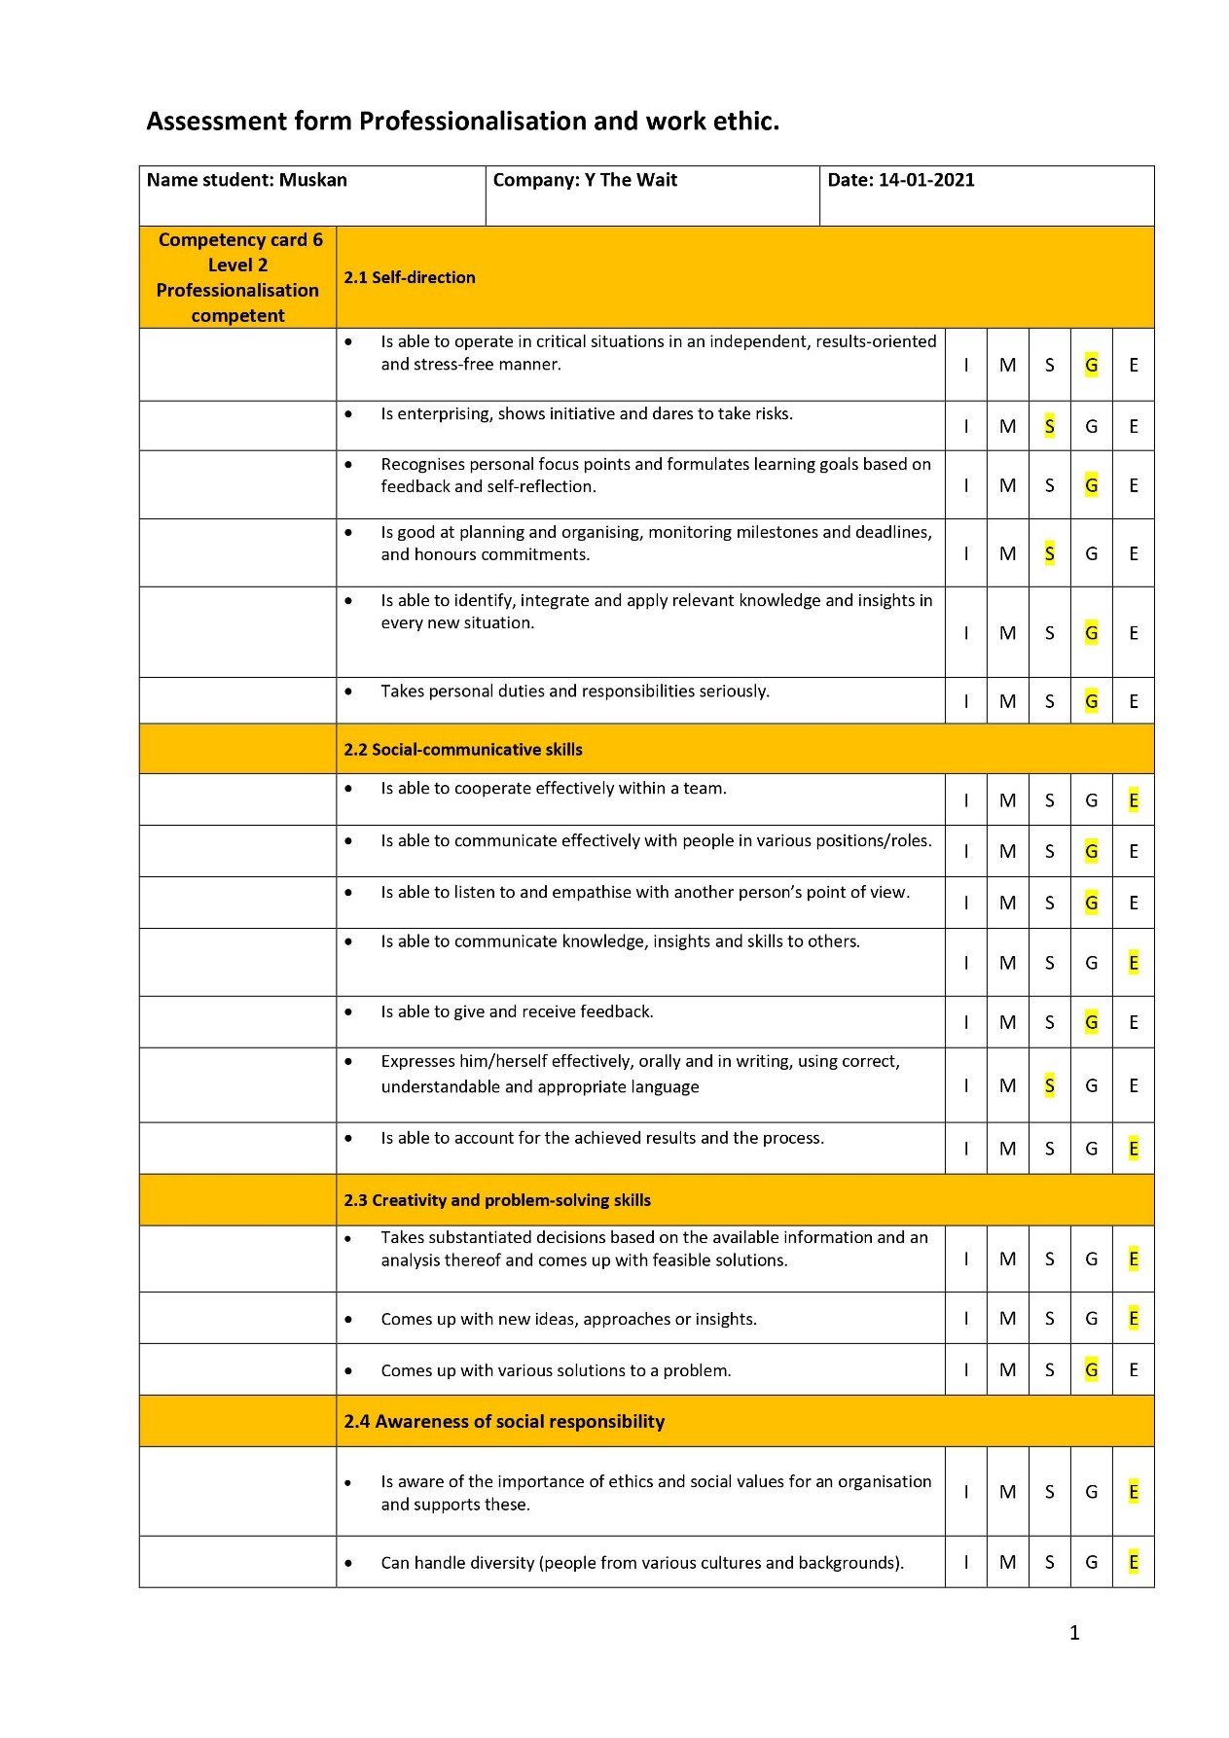

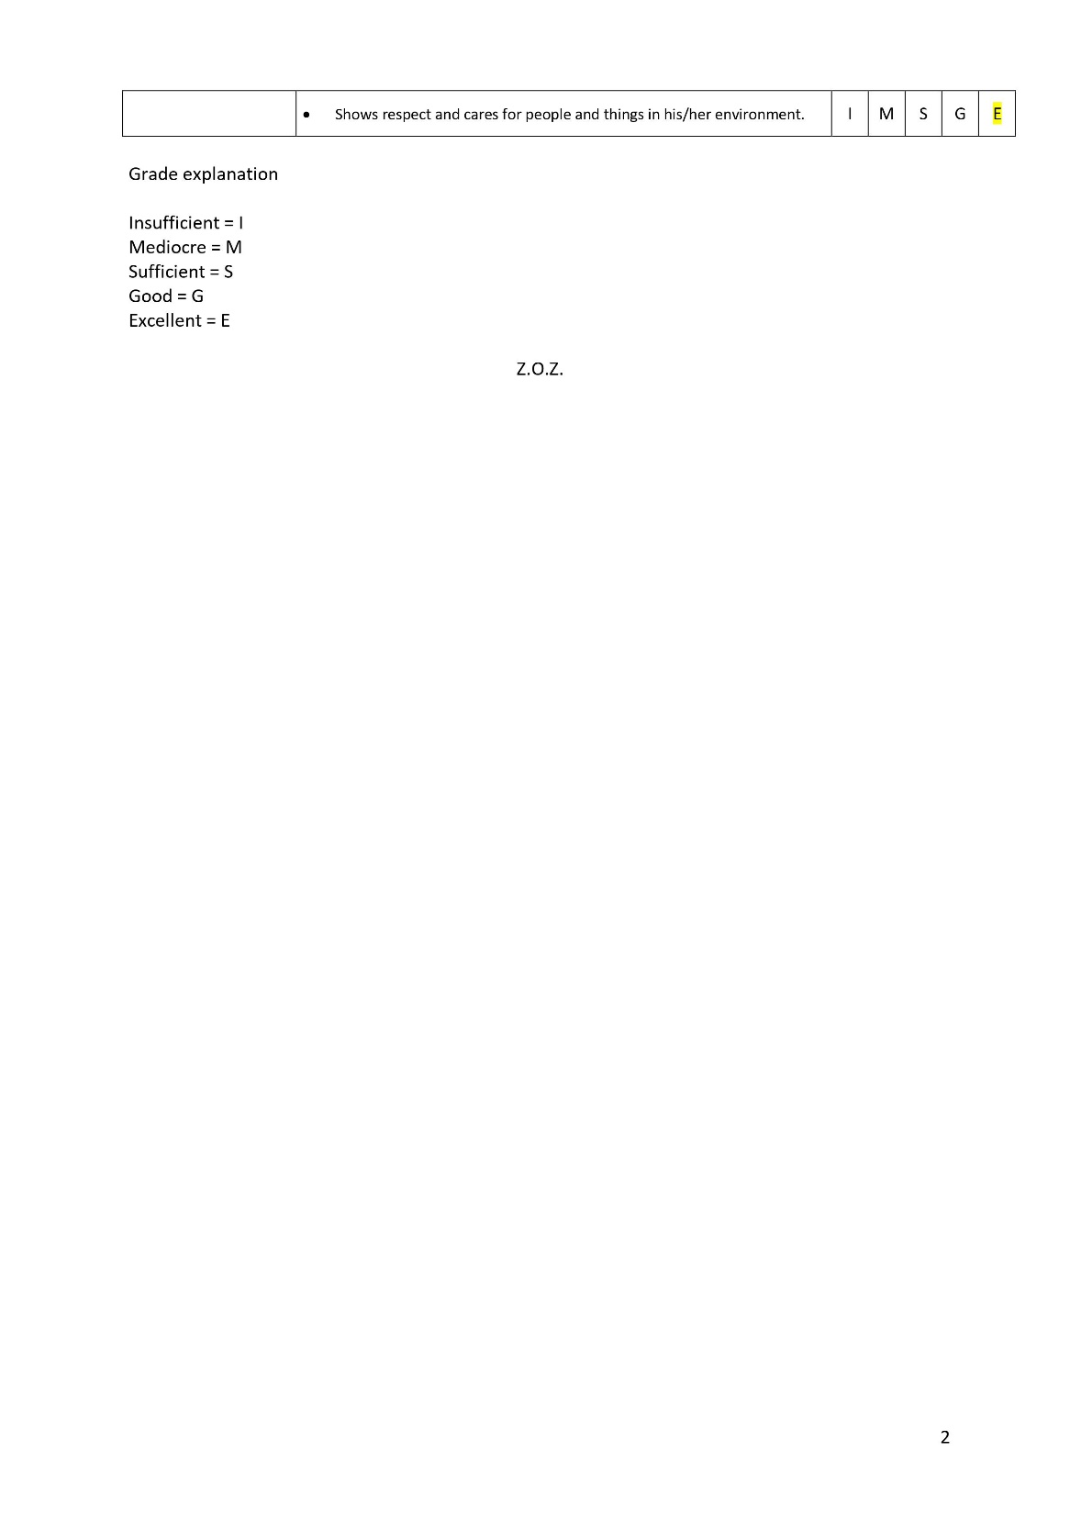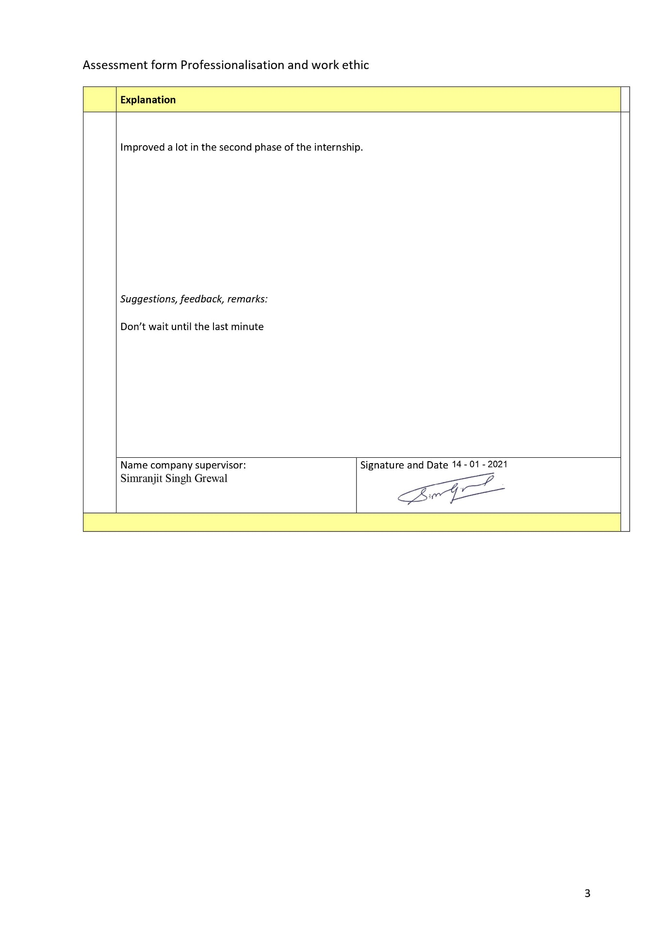

## 6.2 Gannt charts

### Phase 1 Ordering Website Assignment

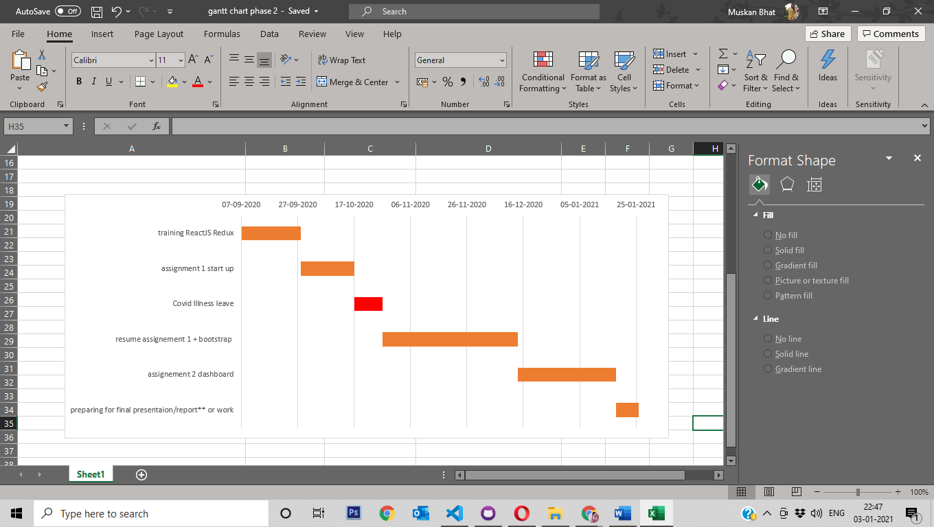

### Phase 2 Dashboard “Finances and Invoices” assignment

